BMCC
Assessment of SLO3 (A)
Fall 2013
MAR 100

Name ____________________ Total Points Earned _______
Industry Analysis (SLO3): Demonstrate the ability to seek, handle and interpret key economic and behavioral data which underpin marketing practice.
The assignment is based out of 10 points. After completion, note the total number of points earned by the student.
- The table below gives the size and growth of the top-5 media tablet brands in Q2 2012 based on global units shipped.
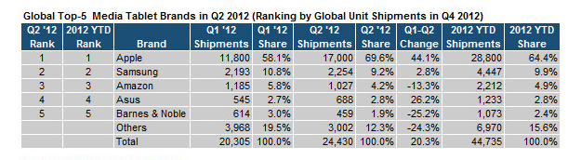
Based on the table answer:
  - What does Q2’12 mean in the above table? [1 pt]

  - Which brand had the most units shipped, globally in Q2’12? [1 pt]
  - Which brand had the highest growth between Q1’12 and Q2 ‘12? [1 pt]

  - Which brand lost the most between Q1’12 and Q2’12? [1 pt]

  - What is the market share of Apple’s media-tablets in Q2’12? [1 pt]

  - If the average selling price of a media tablet is $500, how large is the media tablet market in terms of dollars in 2012? [show your calculation] [2 pt]

  - If Apple shipped 11,800 tablets in Q1’12 and 17,000 in Q2’12, what is the growth rate of tablet sales for Apple company? [show how you calculate growth] [3 pts]

